2A Level 4 #6: Traffic Light Timing Challenge

How long should a traffic light stay yellow?
Assume you are driving at the speed limit of 11.0 m/s. As you approach an intersection 22.0 m wide, you see the light turn yellow. During your reaction time of 0.600 s, you travel at constant speed as you recognize the warning, decide whether to stop or to go through the intersection, and move your foot to the brake if you must stop. The safe rate for your car to accelerate without getting rear-ended is -2.40 m/s².

Before it turns red, the light should stay yellow long enough for you to be able to get to the other side of the intersection without speeding up, if you are too close to the intersection to stop before entering it. (Hint: you also have to consider the time to travel the distance that isn’t long enough for you to stop.)

In addition, the light should stay yellow for the time required to brake at a safe rate so that you do not get rear-ended by slamming on your brakes.

Find the required time interval that the light should stay yellow considering both of these constraints.

Show your process clearly. Diagrams may be useful.

​2A Level 4 #4. Area Challenge:

For velocity versus time graphs, the area bound by the line and the axes represents the displacement. The diagram below shows three different velocity-time graphs; the shaded regions between the line and the time-axis represent the displacement during the stated time interval.
The shaded area is representative of the displacement during from 0 seconds to 6 seconds. This area takes on the shape of a rectangle can be calculated using the appropriate equation. | 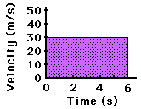
The shaded area is representative of the displacement during from 0 seconds to 4 seconds. This area takes on the shape of a triangle can be calculated using the appropriate equation. | 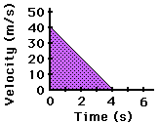
The shaded area is representative of the displacement during from 2 seconds to 5 seconds. This area takes on the shape of a trapezoid can be calculated using the appropriate equation. | 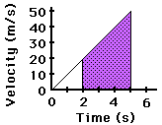

- Use your Holt textbook to solve #37 on p.71. First solve it with equations and a motion map. Then solve it graphically using a v-t graph: Graph the velocity of the rocket in each time period and then calculate the displacement.

- Repeat with #39. Solve with calculations. Then find the displacement of the climber and the first-aid kit graphically.

