Step 2: Background Essay
Adapted from: http://www.neaq.org/conservation_and_research/climate_change/climate_change_basics.php

What is the difference between weather and climate?
Climate describes the average or typical conditions of temperature, relative humidity, cloudiness, precipitation, wind speed and direction, and other meteorological factors that prevail globally or regionally for extended periods. Weather describes the hourly or daily conditions that people experience each day. This is why it’s often said that “Climate is what you expect; weather is what you get.”
People expect the weather to change and experience those changes daily. It’s harder to see how climate is changing because climate is measured over many years rather than as single events. Like weather, climate may change differently in different places. Unlike weather, climate represents trends made up of all the weather variables in a region. Changes in the trends can be subtle, but over time they indicate that what is “normal” is shifting.
What is the Greenhouse Effect?
Water vapor and trace gases in the atmosphere keep Earth about 54°F warmer than it would be without them. This function is often called the greenhouse effect, and the gases that cause it are known as greenhouse gases.The greenhouse effect is a naturally occurring phenomenon that “blankets” the earth and warms it, maintaining the temperature that living things need to survive. Surprisingly, the atmosphere’s most abundant gases — nitrogen, oxygen, and argon — do not influence climate. Instead, it’s the molecules of trace gases, especially water vapor (H₂O), carbon dioxide (CO₂), methane (CH₄), nitrous oxide (N₂O) and ozone (O₃) that strongly absorb infrared radiation emitted by land that has been heated up by the sun. These gases then re-emit infrared radiation back toward the Earth, keeping the heat energy in the Earth-atmosphere system.
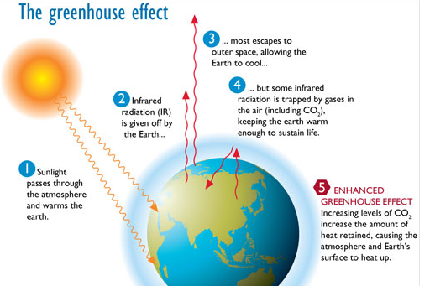

When we burn fossil fuels, we release additional CO₂ that builds up and traps heat that would otherwise escape. This human-caused blanket effect leads to warming of the planet, disrupting the atmospheric balance that keeps the climate stable. This is sometimes called the “Enhanced Greenhouse Effect.”
There is a strong correlation between the rise in global temperature and the increasing concentration of carbon dioxide in the atmosphere. As CO₂ increased from 1850 to 2010, the average temperature on the earth’s surface increased by about 0.8 ° C (1.4 ° F).
What are fossil fuels?
Fossil fuels are the carbon-rich remains of terrestrial plants, marine phytoplankton and zooplankton that have been buried and compressed under sediments for millions of years. Under certain conditions, the remnants of terrestrial plants turn into coal, and the marine organisms are converted into oil or natural gas (methane). Burning fossil fuels that have been mined from deep in the earth or seabed returns ancient fossil carbon, which has been out of circulation, to the atmosphere. Coal is commonly burned in power plants to make electricity. Natural gas has a variety of uses including electricity generation, home heating, and transportation. Oil is primarily used for transportation and for producing materials such as plastics.
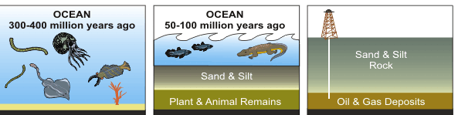

What do scientists predict in terms of climate change?
Earth has warmed at an unprecedented rate over the last hundred years and particularly over the last two decades. All of the top 10 warmest years on record have occurred since 1998. Exactly how much warmer the atmosphere gets will depend on how quickly and effectively people can substantially reduce the activities that are causing rising temperatures.
In 2014, the Intergovernmental Panel on Climate Change (IPCC), published a series of scenarios ranging from “business as usual/no actions taken” to “aggressive actions taken” to reduce climate change. Models based on these scenarios from the IPCC 2014 report predict that by 2100, average global surface temperatures will likely rise by an additional 2 to 8.6°F (1.1 to 4.8 ° C) above the 1986-2005 average. This temperature increase will be accompanied by other environmental changes such as an increase in global sea level by up to 1–2 feet.
During the remainder of this century, different locations will experience different levels of increases in temperature. As an example of what may be in store, New England’s temperature is projected to increase by 6 to 10°F by 2100, in which case Boston’s average temperature would resemble that of Charlotte, North Carolina (a 6 degree increase) or Atlanta, Georgia (a 10 degree increase).

