Document B
The Keeling Curve
Sources: http://www.climatecentral.org/gallery/graphics/keeling_curve, http://science.kqed.org/quest/2014/12/12/the-keeling-curve-explained/
Since the start of the Industrial Revolution in the late 1700s, humans have been emitting more and more CO₂. At the same time, forests all over the world are being cleared for agriculture and development. Deforestation not only leaves fewer plants to absorb the increasing amounts of CO₂, but also adds CO₂ to the air when trees are burned or left to decay.
Until about the mid-20th century many scientists thought that the oceans would easily absorb the excess CO₂ emitted from fossil fuel burning, so there wasn't a great concern over the possible effects of increased emissions in the atmosphere. However, there wasn't a lot of data on the actual concentrations of CO₂ in the atmosphere. In 1958, Charles Keeling of the Scripps Institute of Oceanography began measuring CO₂ levels in the air at a weather station in Hawaii and at the South Pole. After a few years, Keeling observed a steady increase in atmospheric CO₂, an indication that fossil-fuel emissions were building up in the atmosphere. Due to funding cuts, Keeling had to stop measurements at the South Pole, but the weather station in Hawaii continues to measure concentrations of CO₂. The Mauna Loa record, now known as the Keeling Curve, continues to be collected under the direction of Keeling's son, Ralph.
The small annual zigzag visible on the curve is timed with the seasons. Carbon dioxide levels drop during the northern hemisphere spring and summer, when plants are taking CO₂ out of the atmosphere to grow. In the fall and winter, plants and leaves die off and decay, releasing CO₂ back into the atmosphere and causing a small spike. Since most of the world's seasonal vegetation is in the northern hemisphere, the seasonal trend in the Keeling Curve record from Mauna Loa is based on northern hemisphere seasons. The detailed and logical “breathing” of the planet that the Keeling Curve shows is just one of many indicators of its sensitivity and accuracy. The Keeling Curve represents one of the most important geophysical records ever made.

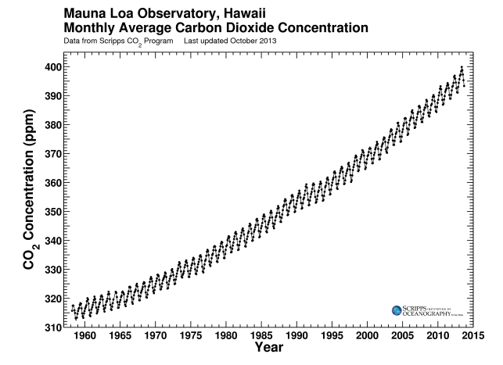
Source: http://scrippsco2.ucsd.edu/history_legacy/keeling_curve_lessons

