Sea Level Rise

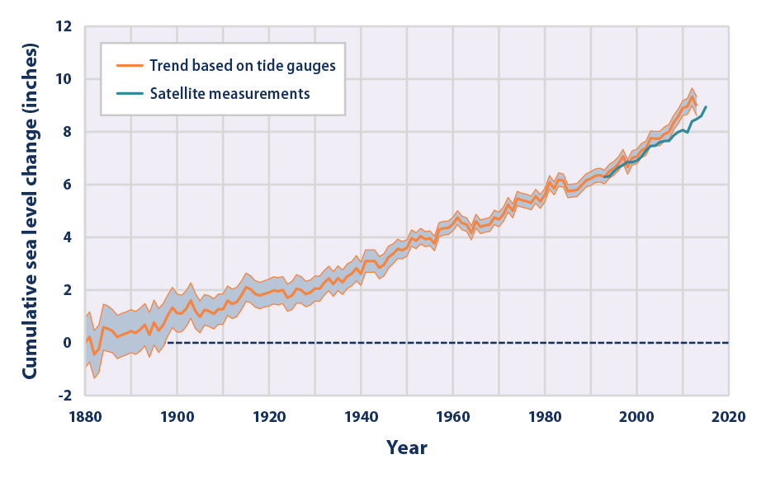
Image from epa.gov
Sea Level Rise
Core samples, tide gauge readings, and, most recently, satellite measurements tell us that over the past century, the Global Mean Sea Level (GMSL) has risen by 4 to 8 inches (10 to 20 centimeters). However, the annual rate of rise over the past 20 years has been 0.13 inches (3.2 millimeters) a year, roughly twice the average speed of the preceding 80 years.
Over the past century, the burning of fossil fuels and other human and natural activities has released enormous amounts of heat-trapping gases into the atmosphere. These emissions have caused the Earth's surface temperature to rise, and the oceans absorb about 80 percent of this additional heat.
The rise in sea levels is linked to three primary factors, all induced by this ongoing global climate change:

Thermal expansion:
When water heats up, it expands. About half of the past century's rise in sea level is attributable to warmer oceans simply occupying more space. Over the 21st century, the IPCC (Intergovernmental Panel on Climate Change) Fourth Assessment projected that thermal expansion will lead to sea level rise of about 17-28 cm.
Melting of glaciers and polar ice caps:
Large ice formations, like glaciers and the polar ice caps, naturally melt back a bit each summer. But in the winter, snows, made primarily from evaporated seawater, are generally sufficient to balance out the melting. Recently, though, persistently higher temperatures caused by global warming have led to greater-than-average summer melting as well as diminished snowfall due to later winters and earlier springs. This imbalance results in a significant net gain in runoff versus evaporation for the ocean, causing sea levels to rise.
Projections for the 21st century contribution to sea level rise from glacier melting is 20-60 cm.
Ice loss from Greenland and West Antarctica:
As with glaciers and the ice caps, increased heat is causing the massive ice sheets that cover Greenland and Antarctica to melt at an accelerated pace. Scientists also believe meltwater from above and seawater from below is seeping beneath Greenland's and West Antarctica's ice sheets, effectively lubricating ice streams and causing them to move more quickly into the sea. Moreover, higher sea temperatures are causing the massive ice shelves that extend out from Antarctica to melt from below, weaken, and break off.
It is expected that melting land ice (e.g. from Greenland and mountain glaciers) will play a more significant role in contributing to future sea level rise.
Projections for the 21st century contribution to sea level rise from:

Greenland ice loss: 2 to 9 cm.
Antarctica ice loss: 17-20 cm.

Albedo effect
Albedo is an expression of the ability of surfaces to reflect sunlight (heat from the sun). Light-coloured surfaces return a large part of the sunrays back to the atmosphere (high albedo). Dark surfaces absorb the rays from the sun (low albedo).

Ice- and snow-covered areas have high albedo, and an ice-covered Arctic reflects solar radiation which otherwise would be absorbed by the oceans and cause the Earth's surface to heat up. The proportion of the Earth's surface that is covered by snow and ice has a great deal to say for how much of the incoming solar radiation is reflected or absorbed. Low albedo (dark surfaces) leads to higher uptake of energy and, hence, warming. Moreover, when more ice and snow melt, there will be more dark surfaces. This is therefore a self-reinforcing effect. Climate change in the Arctic is consequently important for the development of climate change globally.
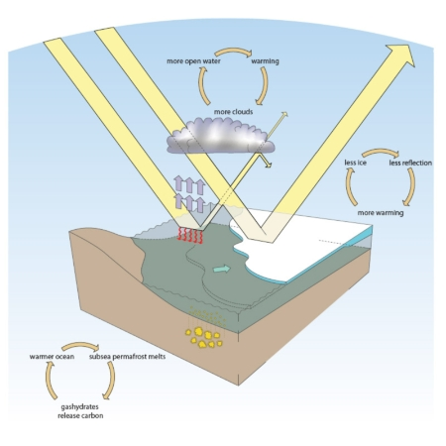

Albedo effect on sea.Illustration: Audun Igestad / Norwegian Polar Institute

Sources:
http://ocean.nationalgeographic.com/ocean/critical-issues-sea-level-rise/
http://www.climate.org/topics/sea-level/index.html#sealevelrise

https://www.ipcc.ch/ipccreports/tar/wg1/409.htm
https://www.ipcc.ch/pdf/unfccc/cop19/3_gregory13sbsta.pdf

